**License Generator Application Documentation**

Since I am not allowed to create my own Repo on Git, I used currently my own one. Here you can find the whole project.

**Git:** [**https://github.com/MatzesGit/MD5_LicenseGenerator.git**](https://github.com/MatzesGit/MD5_LicenseGenerator.git)

The whole project is a part of my C# and dotNetCore learning. This means it is far away from being done and will be constantly improved. The released Version is now 1 Beta means it would be good that you will check from any bugs and forward it me.

Start the program:

The start exe file is located under the bin folder. It will start with the main page to create the new license key.

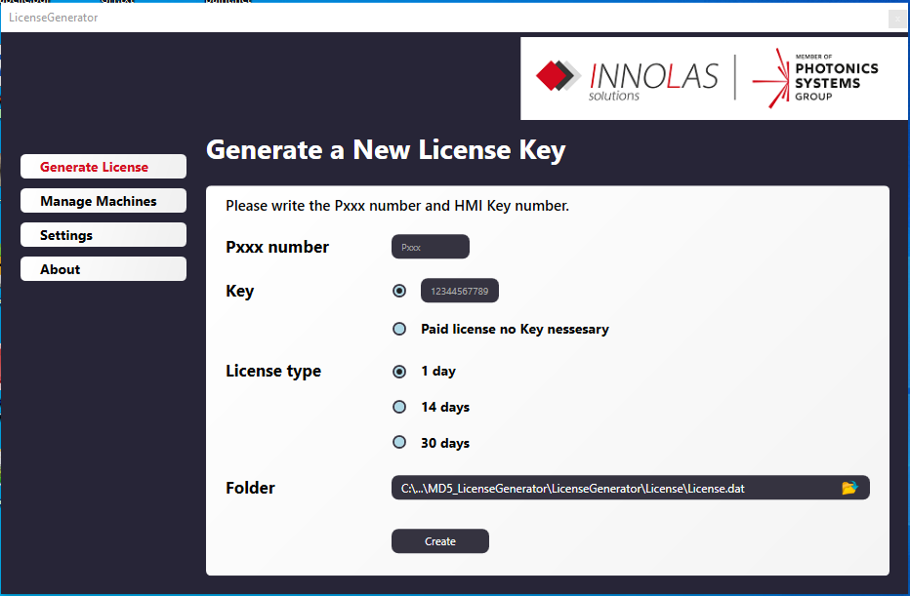

Here you have to write down the Machine Pxxx Number, the machine provided key (not for paid license), and the type of license you want to create.

Under folder you can choose the output directory for the license key. The Standard directory can be changed under Settings. The creation of the actual MD5 hash will be done under Core/CreateMD5Hash.cs.

Manage Machines:

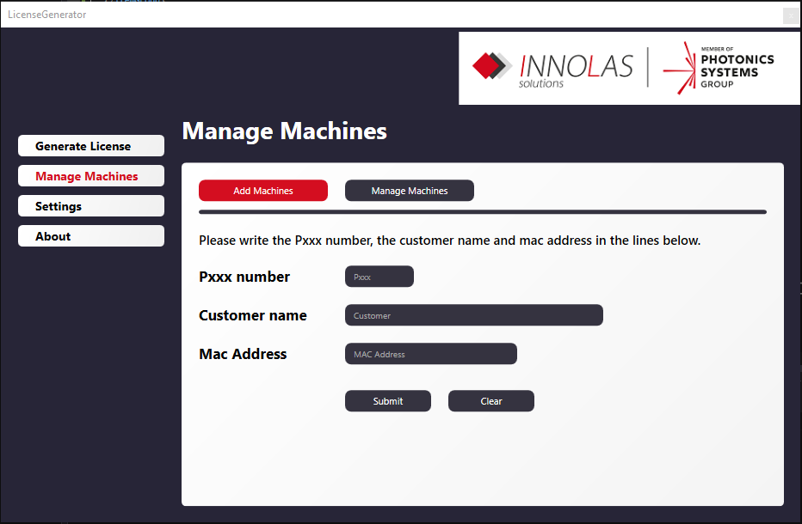

This part is to create a list of machines with there Pxxx numbers and MAC Addresses, so you do not need to remember the MAC address.

Ein Bild, das Text enthält.

Here you can manage the machines. By clicking on a row, you can delete the machine. Currently all machine data will be hold inside the machines.cfg file under the cfg folder.

You can also create them there. Later the plan is to create a database for store the data.

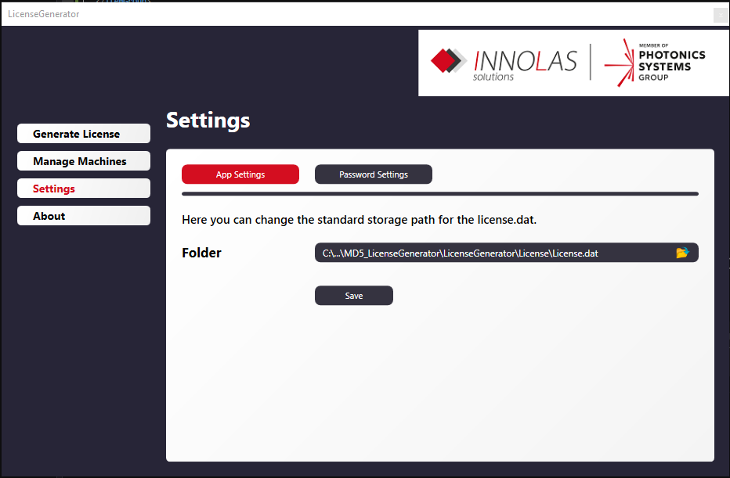

In the Settings, you can change under App Settings the Standard storage folder for the license.dat. This will be the path and folder with will be standardly chosen every time the application will be started.

Under password settings you can change the plc internal passwords for creating the license.

These passwords need to fit the ones who will be set up inside the plc code.

Ein Bild, das Text enthält.

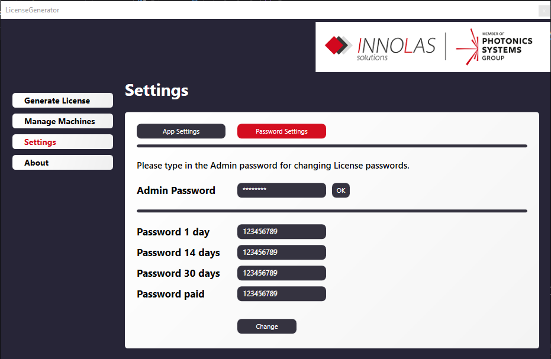

By typing in the Admin Password (Standard “Vative10”) the Application will show you the Passwords.